DECLARE

CURSOR s1 IS SELECT EMPID, basicpay, BONUS, DEPARTMENT FROM payroll1;

v_emp_id payroll1.EMPID%TYPE;

v_basic_salary payroll1.basicpay%TYPE;

v_bonus payroll1.BONUS%TYPE;

v_emp_dep payroll1.DEPARTMENT%TYPE;

v_tax payroll1.TAX%TYPE;

v_consalary payroll1.CONVEYANCE%TYPE;

v_net_salary payroll1.SALARY%TYPE;

BEGIN

UPDATE payroll1 SET BONUS = basicpay * 0.25 WHERE DEPARTMENT = 'CSE';

OPEN s1;

LOOP

FETCH s1 INTO v_emp_id, v_basic_salary, v_bonus, v_emp_dep;

EXIT WHEN s1%NOTFOUND;

IF v_emp_dep != 'CSE' THEN

v_bonus := 0;

END IF;

IF v_basic_salary < 20000 THEN

v_tax := 0.1 * v_basic_salary;

v_consalary := 0.12 * v_basic_salary;

ELSIF v_basic_salary >= 20000 AND v_basic_salary < 50000 THEN

v_tax := 0.2 * v_basic_salary;

v_consalary := 0.16 * v_basic_salary;

ELSE

v_tax := 0.3 * v_basic_salary;

v_consalary := 0.21 * v_basic_salary;

END IF;

v_net_salary := v_basic_salary + v_consalary + v_bonus - v_tax;

UPDATE payroll1

SET TAX = v_tax,

CONVEYANCE = v_consalary,

SALARY = v_net_salary

WHERE EMPID = v_emp_id;

END LOOP;

CLOSE s1;

END;

/

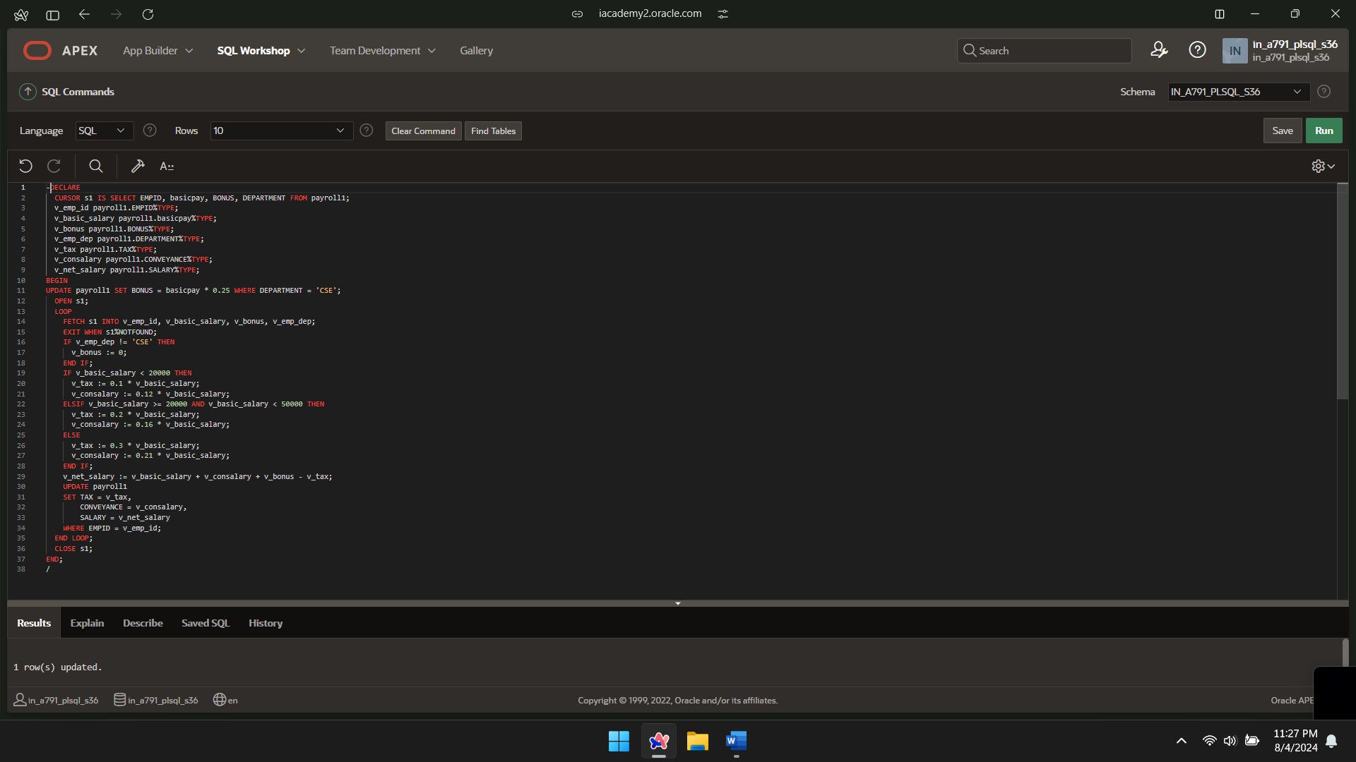  
SELECT *FROM payroll1;

